Question1) Why is 2200000000 not showing?

Answer1)

The maximum integer value (2147483648) is being exceeded that is why a random stored value is being showed.

Question2) Largest Number

Answer2)

#include<stdio.h>

main(){

int a;

int b;

int c;

printf("Enter Any Three Digits \n");

scanf("%d" "%d" "%d", &a, &b, &c);

if(a>b && a>c)

{

printf("a is Largest");

}

else if(b>c && b>a){

printf("b is Largest");

}

else {

printf("c is Largest");

}

}

OUTPUT =

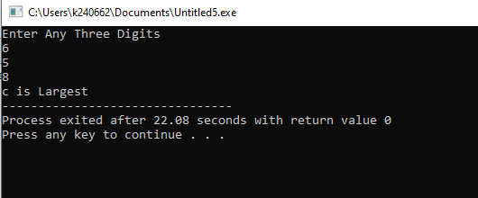

Q3) Conversion from PKR to USD

Ans3)

#include<stdio.h>

main()

{

int a;

int b;

printf("Enter the amount in pkr = \n the conversion rate =");

scanf("%d" "%d", &a, &b);

int USD = a/b;

printf("USD is = %d", USD);

}

OUTPUT =

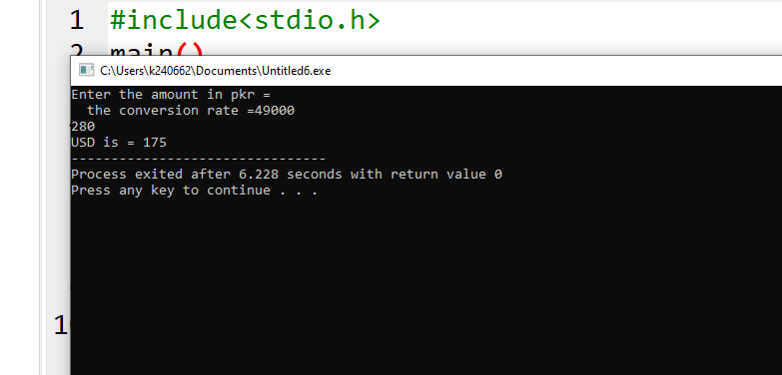

Q4) Even or Odd?

Ans4) #include<stdio.h>

main()

{

int a;

printf("Enter Any Digit \n");

scanf("%d", &a);

if(a%2==0){

printf("The Number is Even");

}

else {

printf("The Number is Odd");

}

}

OUTPUT =

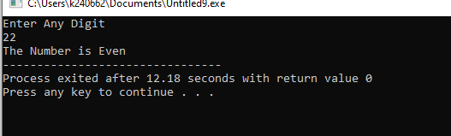

Q6) Cylinder’s Volume Program

Ans6)

#include<stdio.h>

main()

{

int r;

int h;

printf("Enter the Radius and the Height \n");

scanf("%d" "%d", &r, &h);

float Volume = 3.14\*r\*r\*h;

printf("Volume is = %.3f", Volume);

}

OUTPUT=

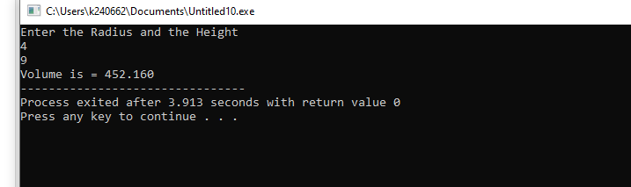

Q5) program for the discounted price

Ans)

#include<stdio.h>

main(){

printf("Enter Original Price:\n");

float a, b, c;

scanf("%f", &a);

if(a < 100 || a>50000){

printf("ERROR : PRICE SHOULD BE BETWEEN 100 AND 50000");

}

printf("Enter Discounted rate:\n");

scanf("%f", &b);

if(b<5 || b>30){

printf("ERROR: ONLY BETWEEN 5 AND 30");

}

c= a\*(1-b/100);

printf("The Final price is: Rs%.2f\n", c);

}

